
L.J. Institute of Computer
Application
L.J. University

Master of Computer Application - Cybersecurity Specialization

MCA Cyber Security

3rd Semester

Subject Name: Cybersecurity Fundamentals & Network Security

Subject Code: MCACS301

Submitted To: Ms. Gagana Narsipalli

Submitted By: Chudasama Vishal
Roll Number: E02

CERTIFICATE

This is to certify that Mr. Chudasama Vishal Bhimashibhai with enrollment number 25004401110069 Semester 3rd has successfully completed his laboratory experiments in the Cybersecurity Fundamentals & Network Security (MCACS301) from the department of MCA Cyber Security during the academic year 2025 - 2028

Date of Submission:

Staff in charge: Ms. Gagana Narsipalli

TABLE OF CONTENT
Sr. No | Experiment Title | Page No | Date of Completion | Marks (Out of 10) | Sign
1 | To capture the live network traffic using Wireshark and apply a display filter to identify HTTP credentials. | 4
2 | To perform network scanning and service enumeration using Nmap, with Metasploitable 2 as the target machine, in order to identify open ports and running services, determine the target operating system, and prepare a complete service inventory. | 9
3 | To analyze a malicious PCAP file using Wireshark, identify different types of suspicious network activity, extract exposed credentials and malicious payloads, detect DNS anomalies, and reconstruct the sequence of attacks using a network attack timeline. | 19
4 | To analyze an event, set up firewall tools, Identify and collect misconfigurations and design a secure network topology for a sample organization using DMZ and IDS. | 26
5 | Configure multiple vlan on a switch and test inter vlan communication with a router on stick cisco packet tracer | 29

Practical-1

AIM: “To capture the live network traffic using Wireshark and apply a display filter to identify HTTP credentials.”
Wireshark is a packet capture tool used to analyse network traffic in real time. It lets us filter packets to inspect source, destination, and protocol details. In this lab, we capture HTTP traffic to find login credentials sent in an unencrypted request.
Procedure
Step 1: Select Network Interface
Open Wireshark and identify the network interface currently connected to the Internet, such as Wi-Fi or Ethernet.
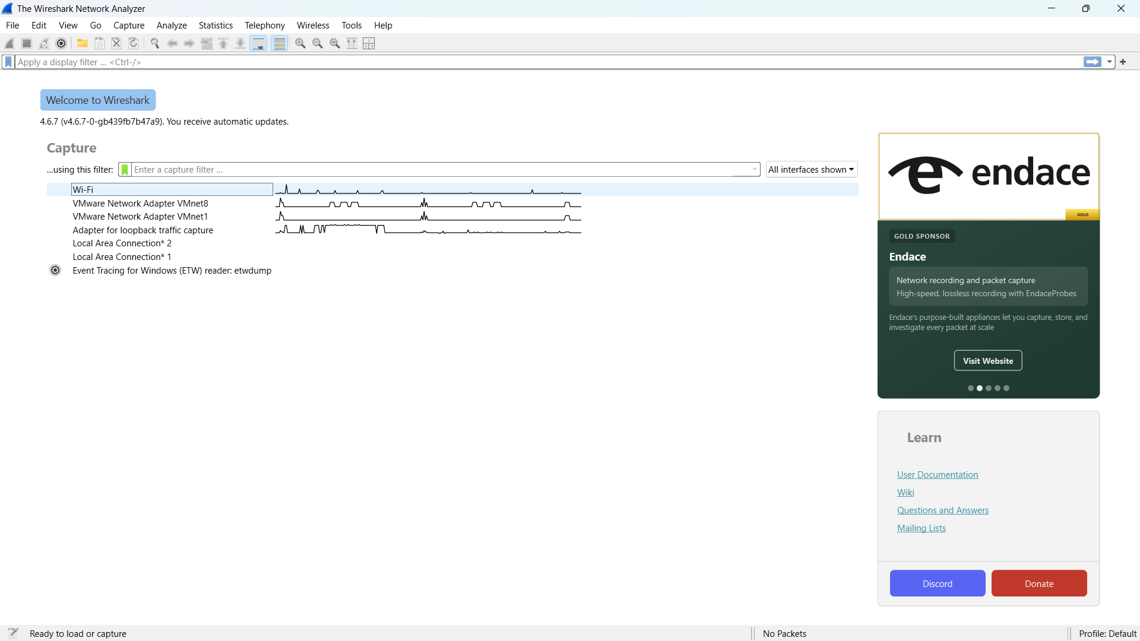
Screenshot 1: Wireshark main screen showing the available network interfaces.
Explanation: The active network interface is highlighted with a box. It is selected to capture the live network traffic.
Highlight: Box the active interface showing live traffic.
Action: Double-click the active interface to start packet capture.

Step 2: Start Packet Capture
Double-click the active network interface to begin capturing live packets.
Wait for a few seconds so that packets start appearing in the packet list.
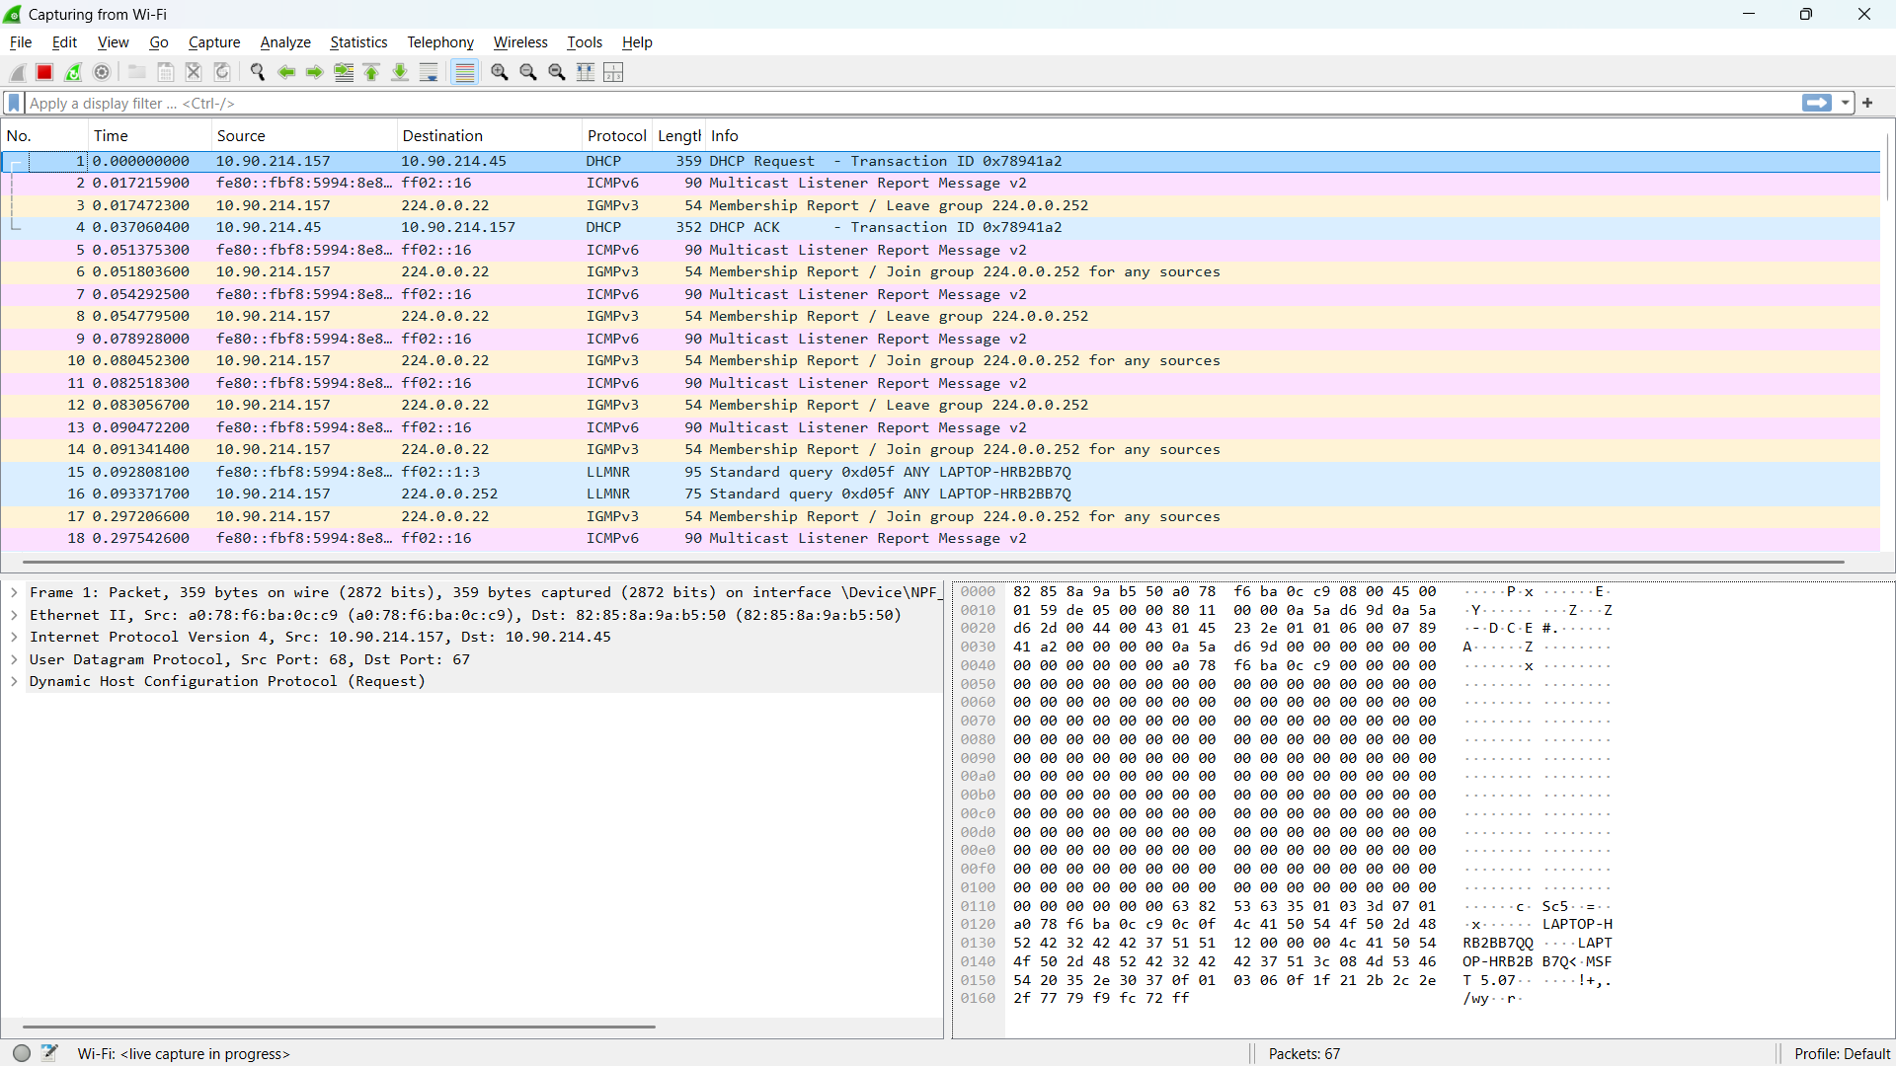
Screenshot 2: Wireshark packet capture window showing live packets.
Explanation: The captured packets are displayed in real time, showing information such as packet number, time, source, destination, protocol, and packet length.
Highlight: Box the Protocol column and a few visible packets.
Action: Keep the capture running for the next step.

Step 3: Visit HTTP Site
To generate HTTP traffic for analysis, open a browser and visit the following HTTP-based demo login page: http://demo.testfire.net/login.jsp
Enter dummy credentials in the login form and click Login while Wireshark is capturing packets.

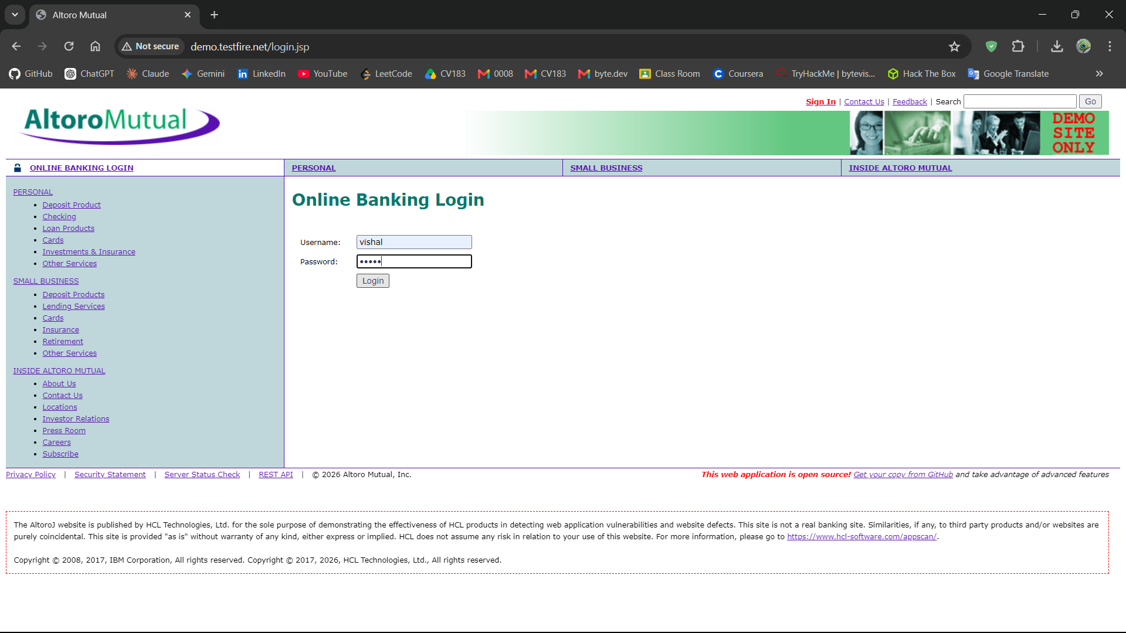
Screenshot 3: HTTP demo login page showing the login form.
Explanation: The HTTP-based demo login page is used to generate a login request containing test credentials for analysis in Wireshark.
Highlight: Box the HTTP URL and the username/password fields.
Action: Enter dummy credentials and click Login. Keep Wireshark capture running.

Step 4: Apply HTTP Display Filter
In Wireshark, stop capturing packets by clicking red colour square icon on top and then click the Display Filter bar at the top and enter:
http
Press Enter.
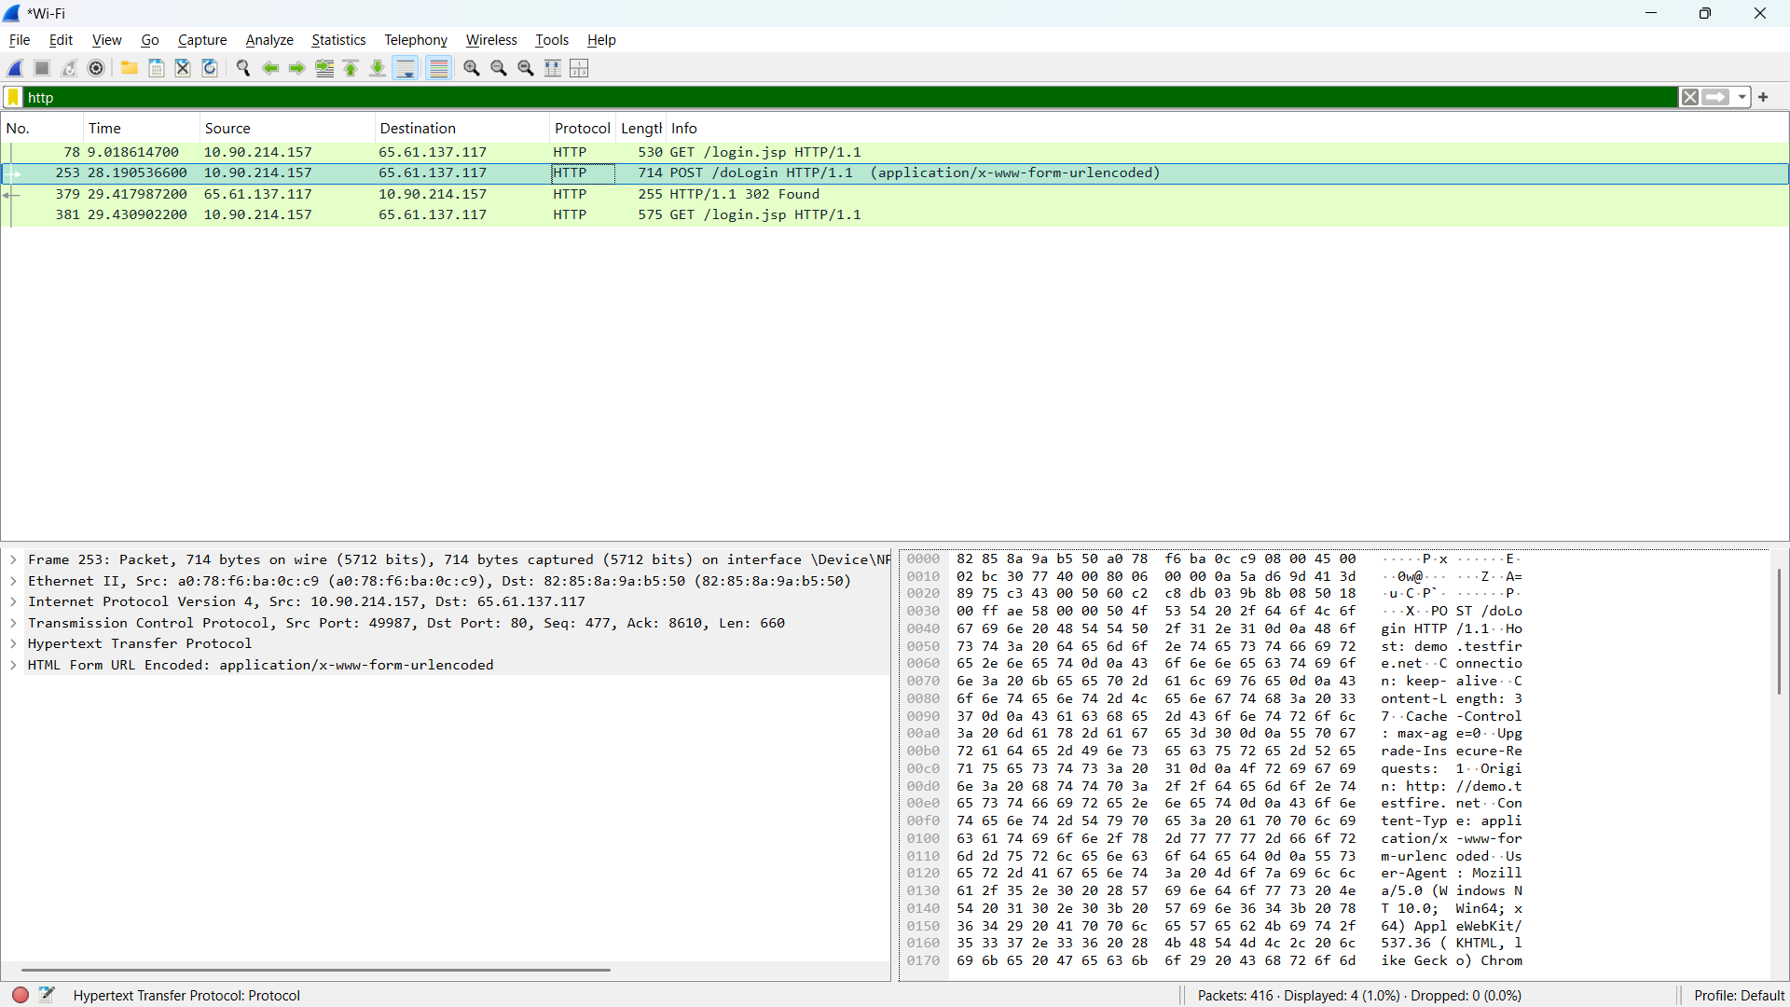
Screenshot 4: Wireshark showing the filtered HTTP packets.
Explanation: The http display filter limits the packet list to HTTP traffic, making it easier to locate the login request generated from the demo website.
Highlight: Box the http filter in the filter bar and the HTTP packets in the Protocol column.
POST /doLogin HTTP/1.1
Action: Locate the HTTP packet corresponding to the login request.

Step 5: Identify HTTP Credentials
Select the HTTP packet corresponding to the login request. (select POST /doLogin HTTP/1.1) In the Packet Details pane, expand the Hypertext Transfer Protocol & HTML Form URL Encoded section.
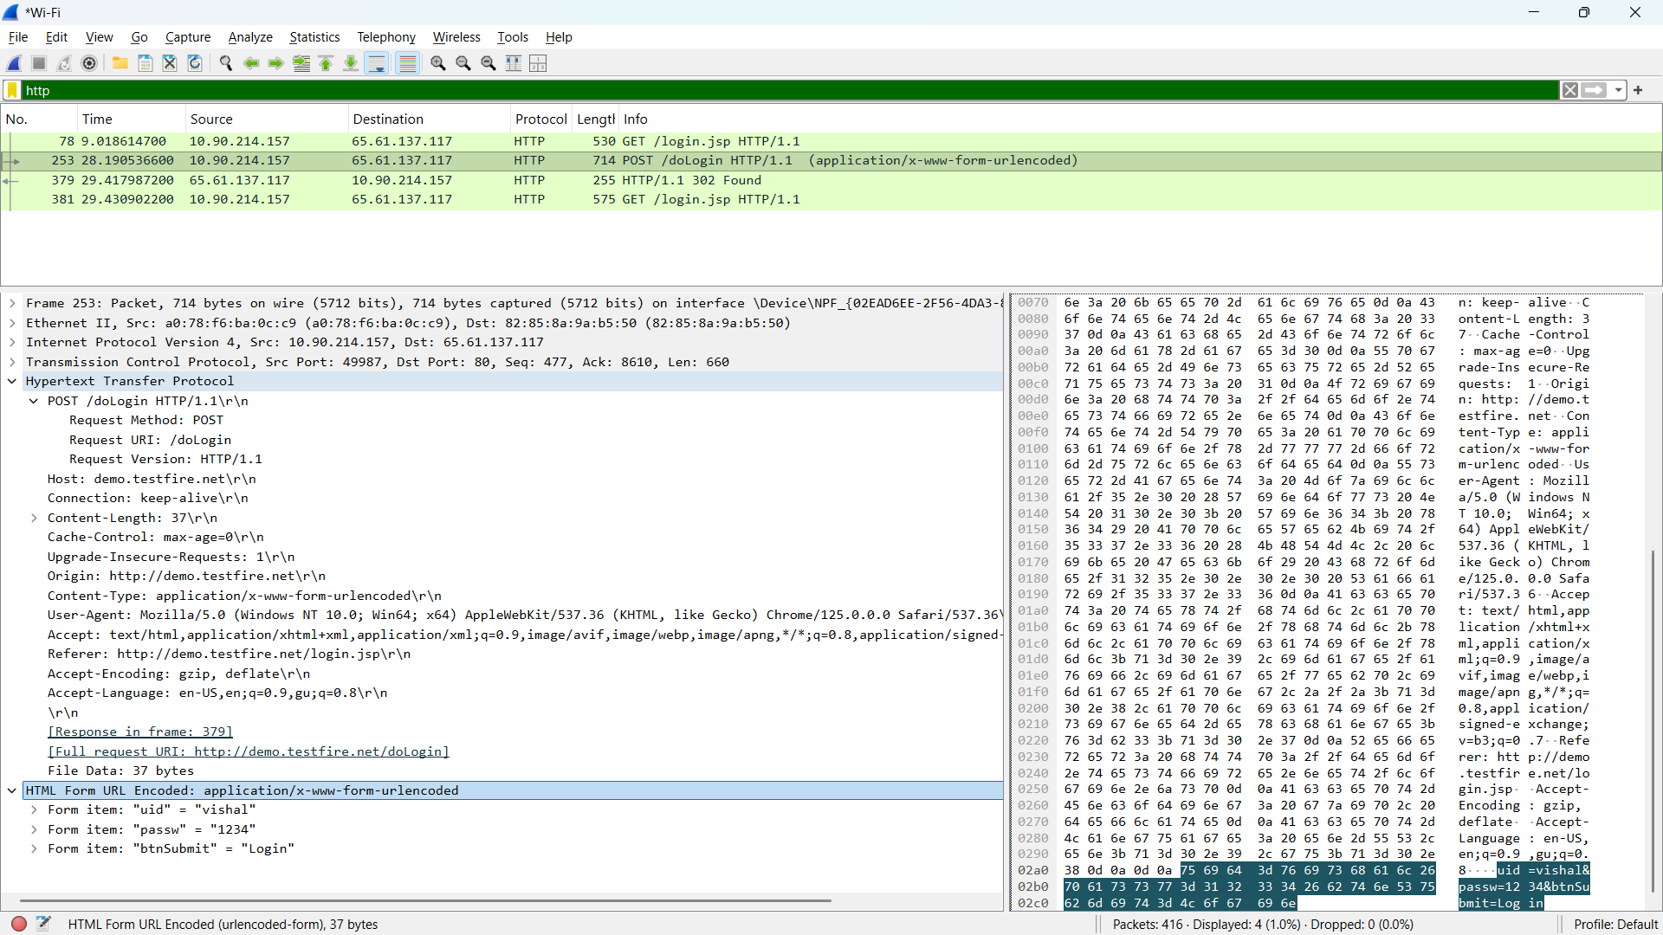
Screenshot 5: Wireshark showing the HTTP login request and submitted test credentials.
Explanation:
The selected HTTP POST request contains the login form data. The HTML Form URL Encoded section shows the submitted username and password, demonstrating that credentials sent over unencrypted HTTP can be viewed in captured network traffic.
Highlight:
- POST /doLogin HTTP/1.1 in the packet details.
- the HTML Form URL Encoded section.
- the uid = vishal and passw = 1234 values.
Action:
Verify that the dummy username and password entered on the HTTP login page are visible in the captured HTTP request.

Conclusion:
Wireshark was successfully used to capture live network traffic and filter HTTP packets using the http display filter. The HTTP POST request was analysed, and the submitted dummy credentials were visible in the captured packet, demonstrating that credentials transmitted over unencrypted HTTP can be exposed during network traffic analysis.

Practical-2

AIM: “To perform network scanning and service enumeration using Nmap, with Metasploitable 2 as the target machine, in order to identify open ports and running services, determine the target operating system, and prepare a complete service inventory.”

Procedure
Step 1: Identify Target IP and Verify Connectivity
On the Metasploitable 2 machine, open the terminal and execute: ifconfig
Identify the IP address of the active network interface.
Then, from Kali Linux, use:
ping -c 4 192.168.184.129
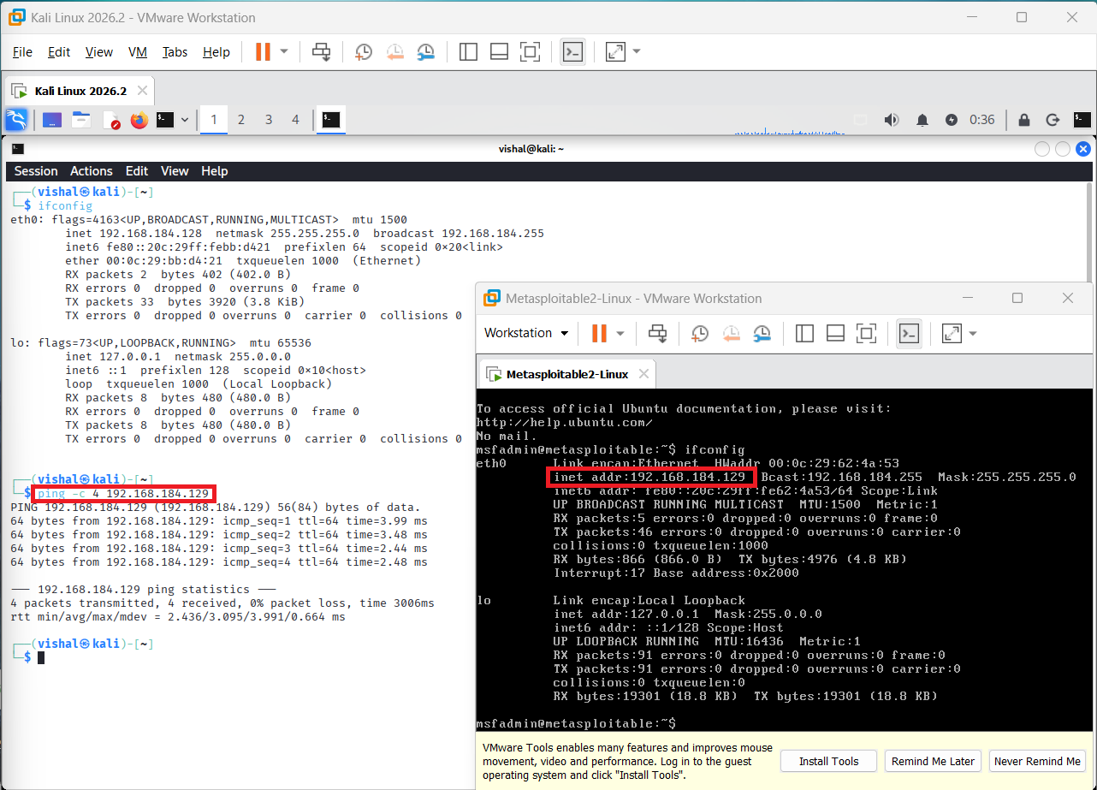
Figure 1: Identification of Metasploitable 2 IP address and successful connectivity verification using Ping from Kali Linux.
POC Explanation
The screenshot shows the ifconfig output of Metasploitable 2, where the target IP address 192.168.184.129 is identified. The Kali Linux terminal then performs a ping test using ping -c 4 192.168.184.129. All four ICMP packets are successfully received with 0% packet loss.
Observation
The target IP address was identified as 192.168.184.129, and successful ping responses confirmed that the target machine is reachable from Kali Linux.

Step 2: Basic Nmap Scan and All TCP Port Scan
1. Basic Nmap Scan
From Kali Linux: nmap 192.168.184.129
This scans the target for the common 1,000 TCP ports and reports which ports are open.
2. Scan All TCP Ports
After that, run: nmap -p- 192.168.184.129
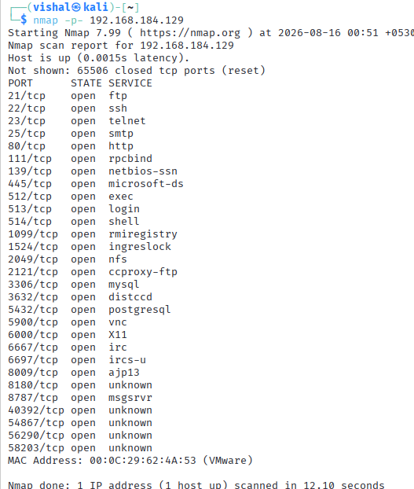
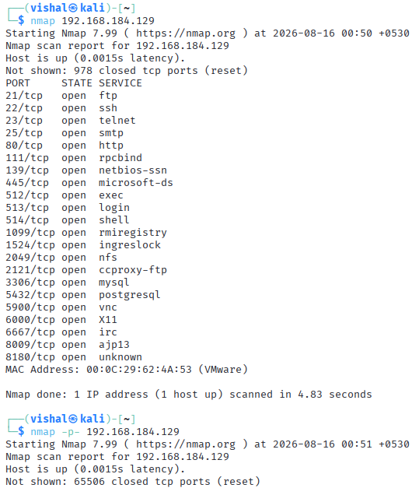
-p- tells Nmap to scan all TCP ports from 1–65535.

Figure 2: Basic Nmap scan and all TCP port scanning of the Metasploitable 2 target.
Explanation
The basic Nmap scan identified 22 open TCP ports among the commonly scanned ports. The all-port scan (-p-) scanned the complete TCP port range from 1 to 65535 and identified 29 open TCP ports on the target.
The all-port scan additionally discovered ports such as 3632, 6697, 8787, 40392, 54867, 56290, and 58203, which were not reported by the basic scan.
Observation
The basic scan identified 22 open TCP ports, while the all-port scan identified 29 open TCP ports. The all-port scan revealed additional open ports outside the default common-port scan range.

Step 3: Service and Version Detection
Now we identify which services are running on the open ports and their versions.
Command used: nmap -sV 192.168.184.129
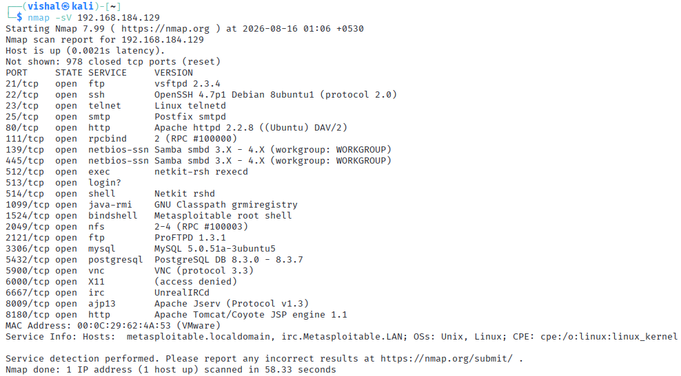
Figure 3: Service and version detection of open ports on the Metasploitable 2 target using Nmap.
Explanation
The -sV option was used to detect the service names and versions running on the open TCP ports of the target. Nmap identified services including FTP, SSH, Telnet, HTTP, Samba, MySQL, PostgreSQL, VNC, IRC, and Apache Tomcat along with their detected versions.
Observation
The service and version scan successfully identified the services running on the open ports. Nmap detected 22 services in the default scan range and provided version information for several services, which can be used to prepare the target's service inventory.

Step 4: Operating System Detection

Run: nmap -O 192.168.184.129
-O = Operating System detection.

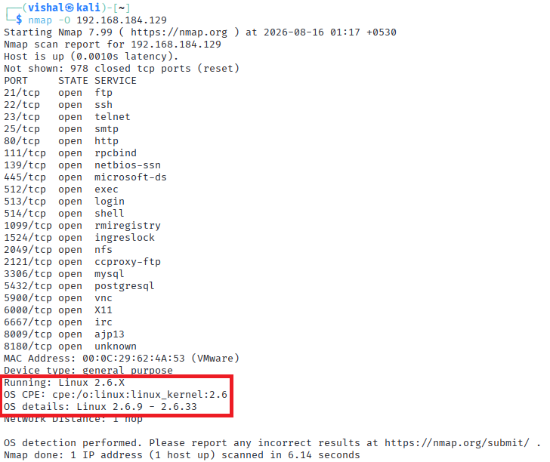
Figure 4: Operating system detection of the Metasploitable 2 target using Nmap.
Explanation
The -O option was used to perform operating system detection. Nmap identified the target as a general-purpose Linux system and estimated the kernel version as Linux 2.6.X.

Observation
Nmap detected the target as a general-purpose Linux system running a Linux 2.6.X kernel, with the estimated version range Linux 2.6.9–2.6.33. The target was found to be one network hop away.

Step 5: TCP SYN Scan
Command used: nmap -sS 192.168.184.129
The -sS option performs a TCP SYN scan. It checks whether TCP ports are open by sending SYN packets and analyzing the responses.
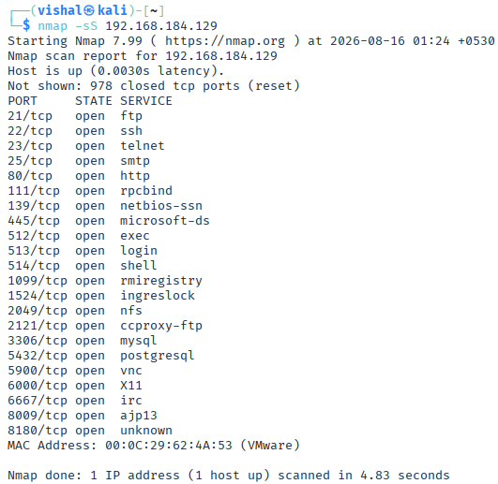
Figure 5: TCP SYN scan performed on the Metasploitable 2 target using Nmap.
Explanation
The screenshot shows Nmap performing a TCP SYN scan against 192.168.184.129. The scan identified the target as active and detected 22 open TCP ports in the default scanned range.

Observation
The SYN scan successfully identified the target as active and detected 22 open TCP ports, including FTP (21), SSH (22), HTTP (80), MySQL (3306), PostgreSQL (5432), VNC (5900), and other services.

Step 6: TCP Connect Scan
Command used: nmap -sT 192.168.184.129
The -sT option performs a TCP Connect scan, which establishes a complete TCP connection to determine whether a port is open.

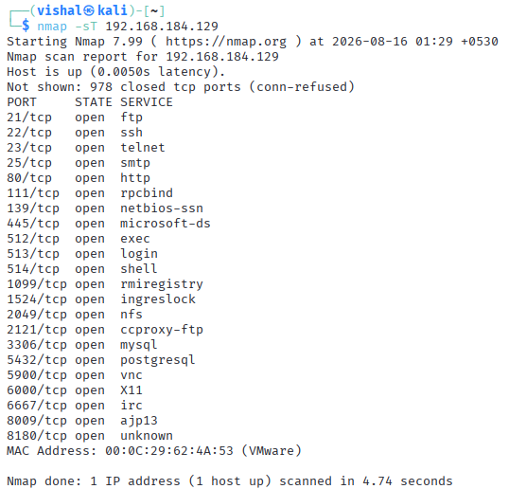
Figure 6: TCP Connect scan performed on the Metasploitable 2 target using Nmap.
Explanation
The screenshot shows a TCP Connect scan against 192.168.184.129. The target was found to be active, and Nmap identified 22 open TCP ports in the default scanned range.

Observation
The TCP Connect scan successfully identified the target as active and detected 22 open TCP ports. The results were consistent with the earlier SYN scan, confirming the availability of the identified TCP services.

Step 7: Service and Operating System Detection
Command used: nmap -sV -O 192.168.184.129
- -sV → detects services and versions
- -O → detects the operating system

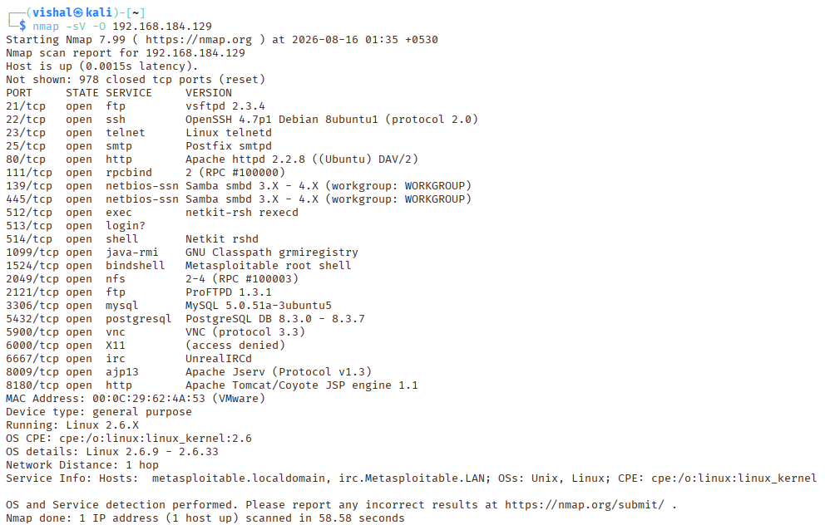
Figure 7: Combined service/version and operating system detection of the Metasploitable 2 target using Nmap.
Explanation
The -sV -O options were used together to enumerate the services and their versions and to identify the operating system of the target. Nmap detected multiple services including FTP, SSH, Telnet, HTTP, Samba, MySQL, PostgreSQL, VNC, IRC, and Apache Tomcat.
The OS detection identified the target as a general-purpose Linux system running Linux 2.6.X, with an estimated kernel range of Linux 2.6.9–2.6.33.

Observation
The combined scan successfully enumerated the target's open services and their detected versions and identified the operating system as Linux 2.6.X. This information provides the primary data required to prepare the service inventory of the Metasploitable 2 system.

Step 8: Save Nmap Scan Results
Command used:
nmap -sV -O 192.168.184.129 -oN nmap_scan.txt
Then the saved file was verified using: cat nmap_scan.txt

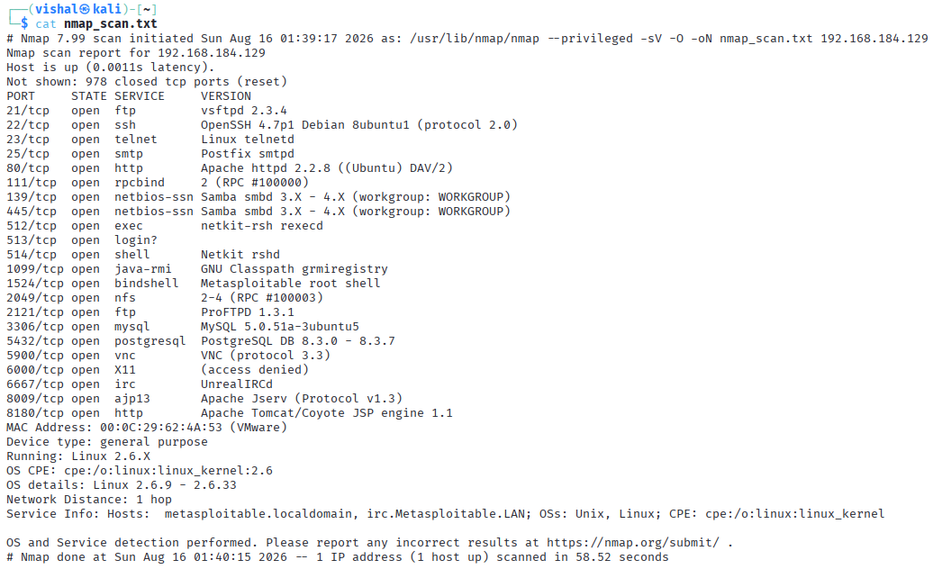
Figure 8: Verification of saved Nmap service and OS scan results in a text file.
Explanation
The screenshot shows the contents of nmap_scan.txt, confirming that the Nmap scan results were successfully saved in normal text format. The file contains the detected open ports, services, service versions, MAC address, and operating system information of the Metasploitable 2 target.

Observation
The Nmap scan results were successfully saved to nmap_scan.txt. The saved file contains the service enumeration and OS detection results, providing a persistent record that can be used for analysis and service inventory preparation.

Final Observation
Nmap successfully identified the Metasploitable 2 host at 192.168.184.129 and confirmed network connectivity. The scans discovered multiple open TCP ports and running services. Service/version detection identified services such as FTP, SSH, Telnet, HTTP, Samba, MySQL, PostgreSQL, VNC, IRC, and Apache Tomcat. OS detection identified the target as a general-purpose Linux 2.6.X system.

Service Inventory
This table is based directly on nmap -sV -O result:
Port | Protocol | Service | Version
21 | TCP | FTP | vsftpd 2.3.4
22 | TCP | SSH | OpenSSH 4.7p1 Debian 8ubuntu1
23 | TCP | Telnet | Linux telnetd
25 | TCP | SMTP | Postfix smtpd
80 | TCP | HTTP | Apache httpd 2.2.8 ((Ubuntu) DAV/2)
111 | TCP | RPCBind | 2 (RPC #100000)
139 | TCP | NetBIOS | Samba smbd 3.X - 4.X
445 | TCP | NetBIOS | Samba smbd 3.X - 4.X
512 | TCP | exec | netkit-rsh rexecd
513 | TCP | login | Unknown
514 | TCP | shell | Netkit rshd
1099 | TCP | Java RMI | GNU Classpath grmiregistry
1524 | TCP | Bindshell | Metasploitable root shell
2049 | TCP | NFS | 2-4 (RPC #100003)
2121 | TCP | FTP | ProFTPD 1.3.1
3306 | TCP | MySQL | MySQL 5.0.51a-3ubuntu5
5432 | TCP | PostgreSQL | PostgreSQL 8.3.0 - 8.3.7
5900 | TCP | VNC | VNC protocol 3.3
6000 | TCP | X11 | Access denied
6667 | TCP | IRC | UnrealIRCd
8009 | TCP | AJP13 | Apache Jserv (Protocol v1.3)
8180 | TCP | HTTP | Apache Tomcat/Coyote JSP engine 1.1
Other inventory details:
Attack Machine (Kali Linux) IP | 192.168.184.128
Target Machine (Metasploitable) IP | 192.168.184.129
Operating System | Linux 2.6.X
OS Details | Linux 2.6.9 - 2.6.33
Device Type | General purpose
Network Distance | 1 hop

- What is vsftpd 2.3.4?
- vsftpd 2.3.4 is a vulnerable version of the Very Secure FTP Daemon, an FTP server for Linux/Unix systems. It is commonly used in penetration-testing labs because it contains a known backdoor vulnerability (CVE-2011-2523).
- How to check whether vsftpd 2.3.4 is vulnerable without exploiting it?
- You can perform version detection and compare the detected version with the known vulnerable version.
- We example, with Nmap: nmap -sV -p 21 <target-ip>
- If the result shows: 21/tcp open ftp vsftpd 2.3.4
- We can identify that the target is running vsftpd 2.3.4, which is associated with CVE-2011-2523.
- We can also use: nmap -p 21 --script ftp-syst <target-ip>
- This gathers FTP service information without attempting the known backdoor exploit.
- What is the difference between a SYN scan and a Connect scan? Which scan provides more information/evidence about the target machine?
- SYN Scan vs Connect Scan
Feature | SYN Scan (-sS) | Connect Scan (-sT)
TCP connection | Does not complete the full TCP handshake | Completes the full TCP handshake
Speed | Usually faster | Usually slower
Stealth | More stealthy | More noticeable
Requires privileges | Usually requires root/admin privileges | Usually does not require special privileges
Evidence | Shows port state through SYN/SYN-ACK/RST responses | Gives stronger evidence that a complete TCP connection can be established
- A Connect scan (-sT) provides stronger direct evidence that the TCP connection can actually be completed because it performs the complete three-way handshake.
- However, a SYN scan (-sS) is generally preferred for normal port scanning because it is faster and does not complete the connection.

Conclusion
The Nmap scanning and service enumeration practical was successfully completed against Metasploitable 2. Different Nmap scanning techniques were used to identify open TCP ports, enumerate running services and their versions, detect the target operating system, and perform TCP SYN and Connect scans. The obtained results were saved to a text file and used to prepare a complete service inventory of the target system.

Practical-3

AIM: “To analyze a malicious PCAP file using Wireshark, identify different types of suspicious network activity, extract exposed credentials and malicious payloads, detect DNS anomalies, and reconstruct the sequence of attacks using a network attack timeline.”
Requirements
- Kali Linux / Windows
- Wireshark
- malicious_pcap_final.pcap
- ftp-capture.pcap

Procedure
Step 1: Open and Analyze the Malicious PCAP File
Open Wireshark.
Go to: File → Open → malicious_pcap_final.pcap
Now look at the Protocol column. You should see different protocols such as:
FTP, HTTP, DNS, TCP, UDP
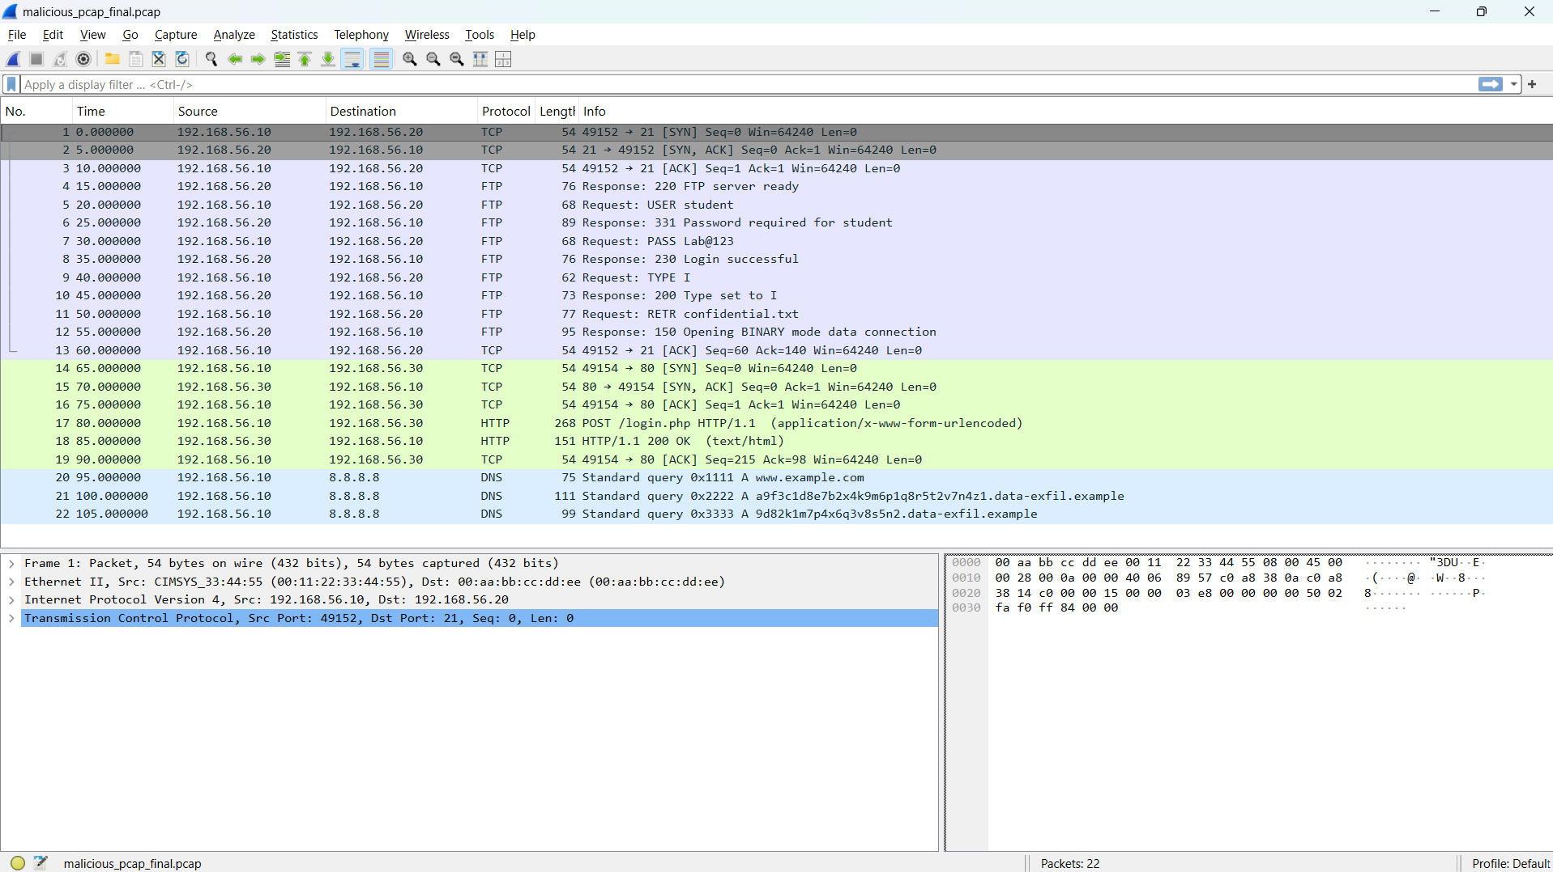
Figure 1: Overview of the malicious PCAP file analyzed using Wireshark
POC Explanation
A PCAP file contains captured network packets. Wireshark allows us to inspect these packets and identify suspicious communication, credentials, and attack activity.

Step 2: Analyze FTP Credentials from ftp-capture.pcap
Now, Open the second PCAP file
File → Open → ftp-capture.pcap
In the Wireshark Display Filter bar, enter: ftp
Press Enter.
Now inspect the Info column and the packet details.
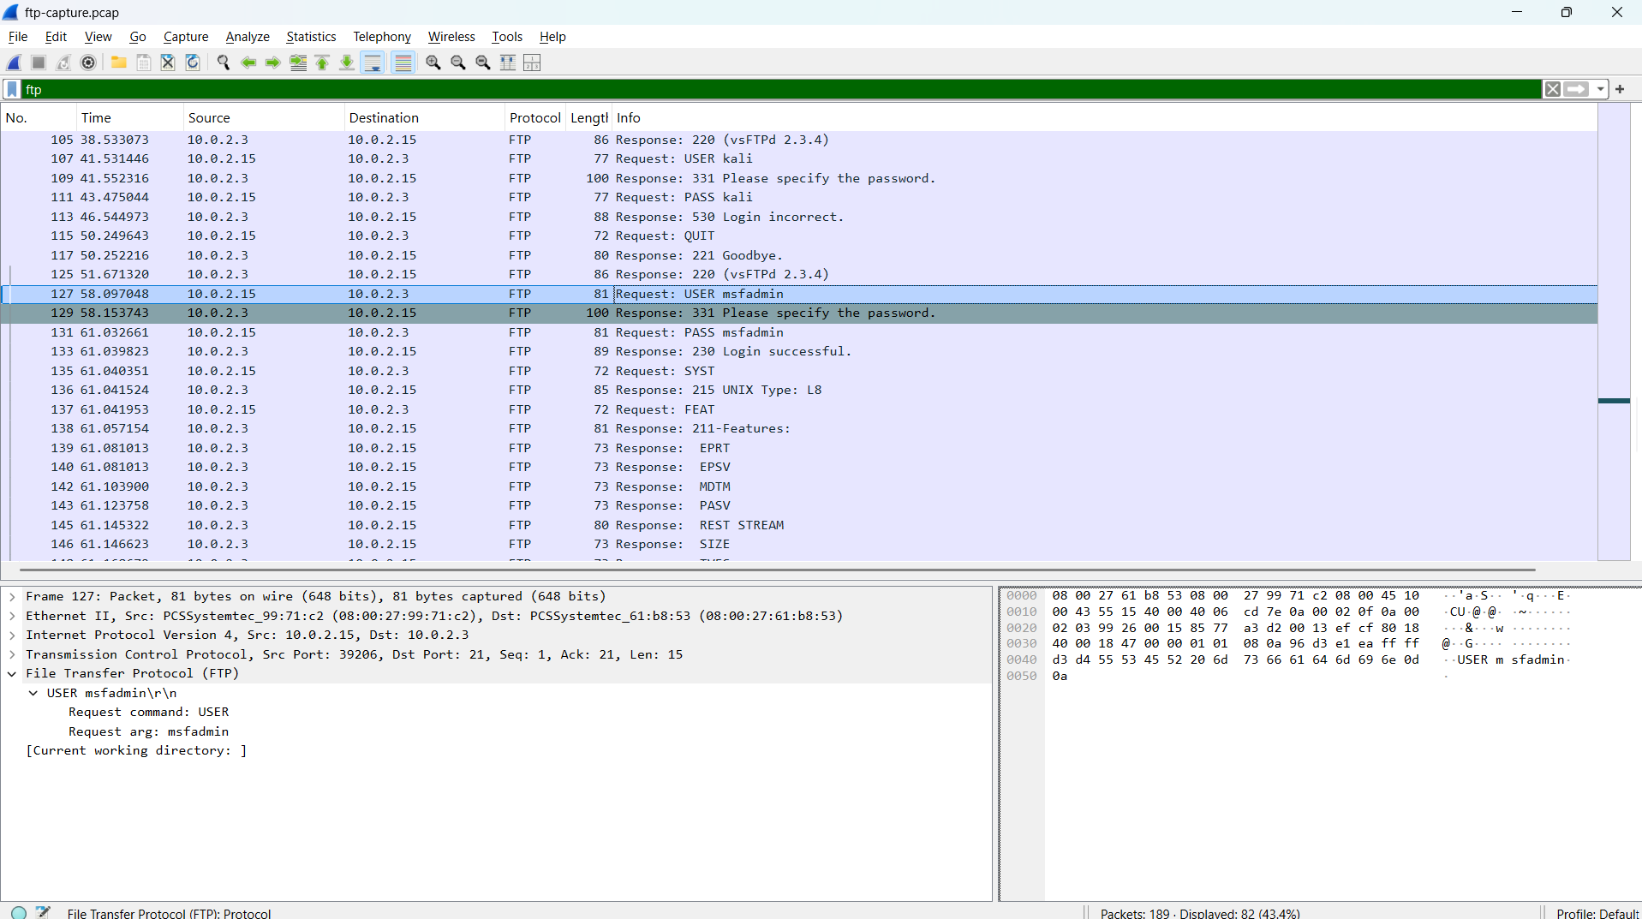
Figure 2: FTP credentials captured in plain text using Wireshark
POC Explanation
The FTP capture contains authentication attempts with credentials transmitted in plain text.
We can observe credentials such as:
Username: msfadmin
Password: msfadmin
The capture also contains an Anonymous FTP login and other unsuccessful login attempts.
FTP does not encrypt its authentication traffic. Therefore, when FTP packets are captured, the USER and PASS commands can be read directly in Wireshark.
This demonstrates that plain FTP can expose login credentials to anyone who is able to capture the network traffic.
Step 3: Analyze FTP File Access / Suspicious Activity
Now return to the first PCAP file:
File → Open → malicious_pcap_final.pcap
Apply the filter: ftp
Inspect the Info column and locate the file-transfer commands.
We can observe commands such as:
TYPE I
RETR confidential.txt
Select the packet containing:
RETR confidential.txt
Then right-click it and select:
Follow → TCP Stream
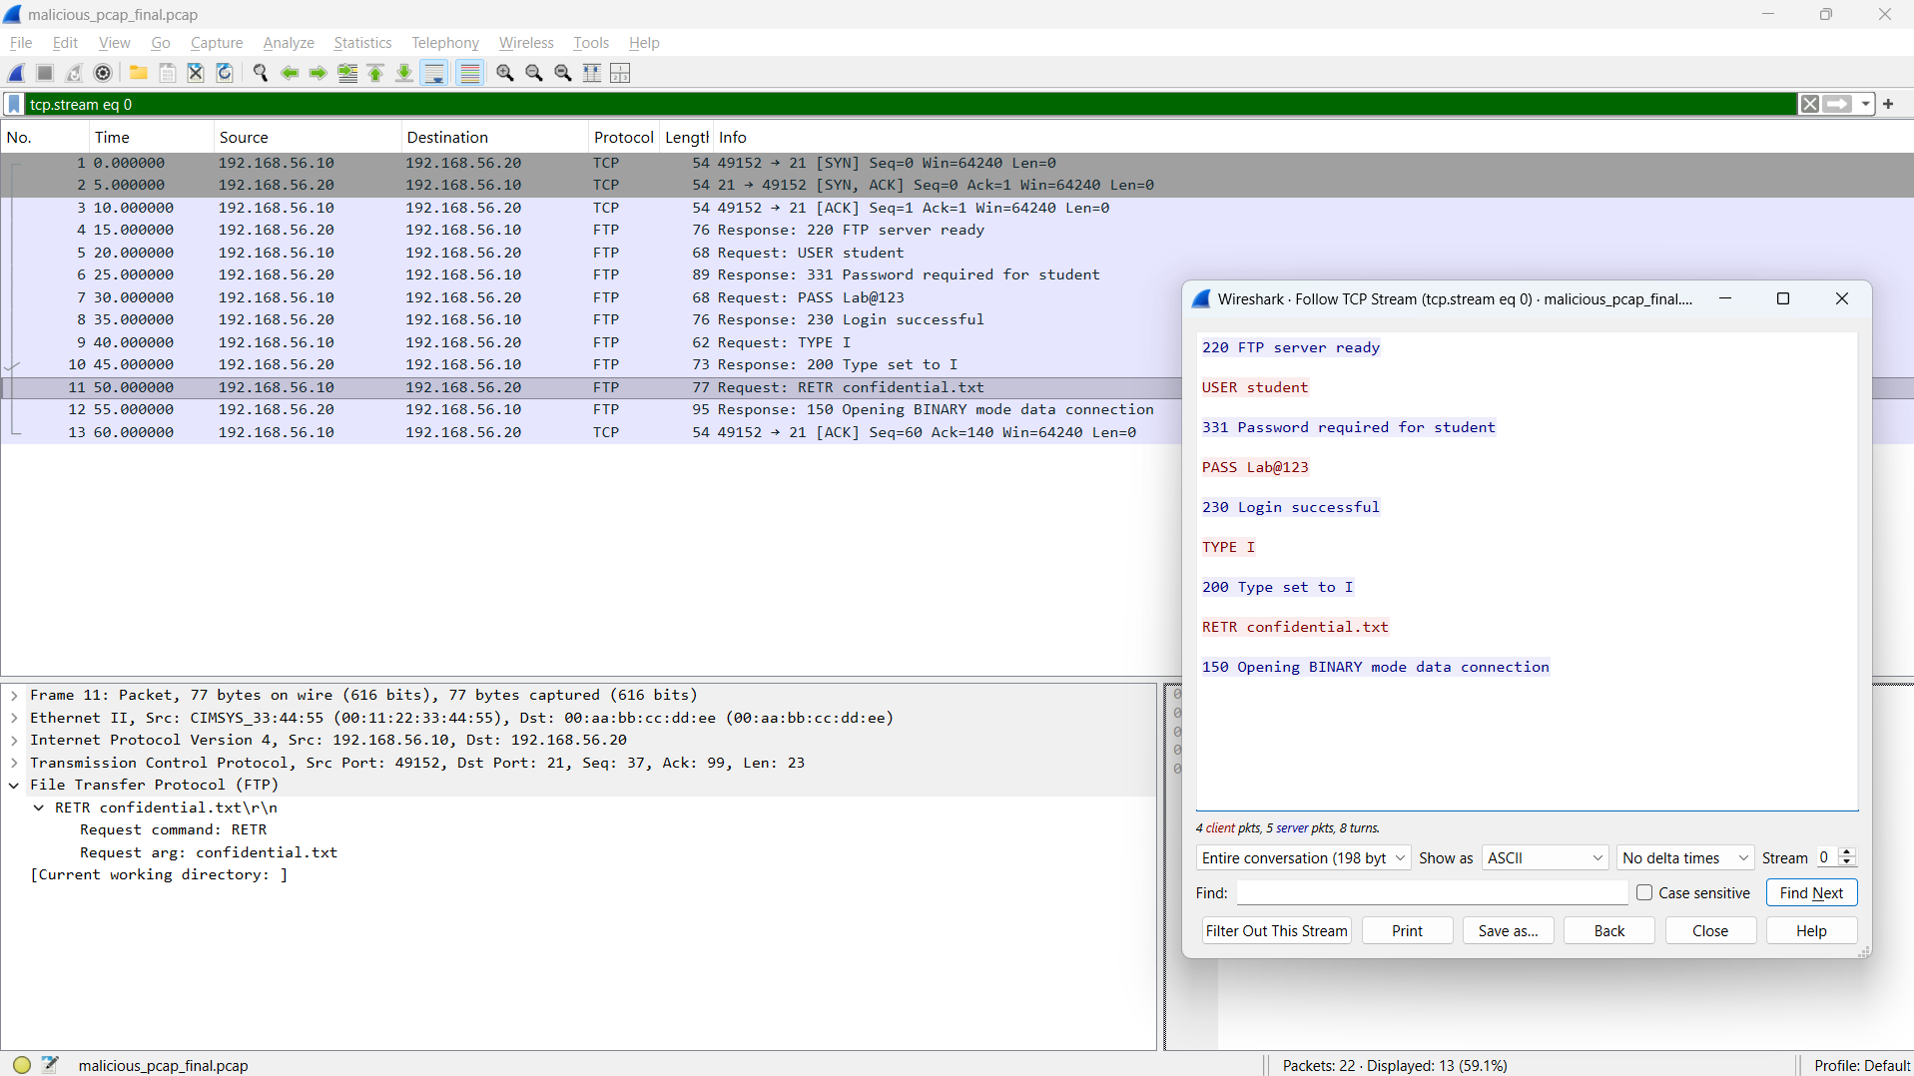
Figure 3: FTP file retrieval activity showing confidential.txt
POC Explanation
The FTP session shows that after authentication, the client requests the file:
RETR confidential.txt
The RETR command is used to retrieve a file from an FTP server. This shows that a file named confidential.txt was accessed during the FTP session.
Step 4: Detect DNS Anomaly / Possible DNS Tunneling
In the Wireshark Display Filter bar, enter: dns
Press Enter.
Now inspect the DNS queries in the Info column.
Look for unusually long or random-looking domain/subdomain names.
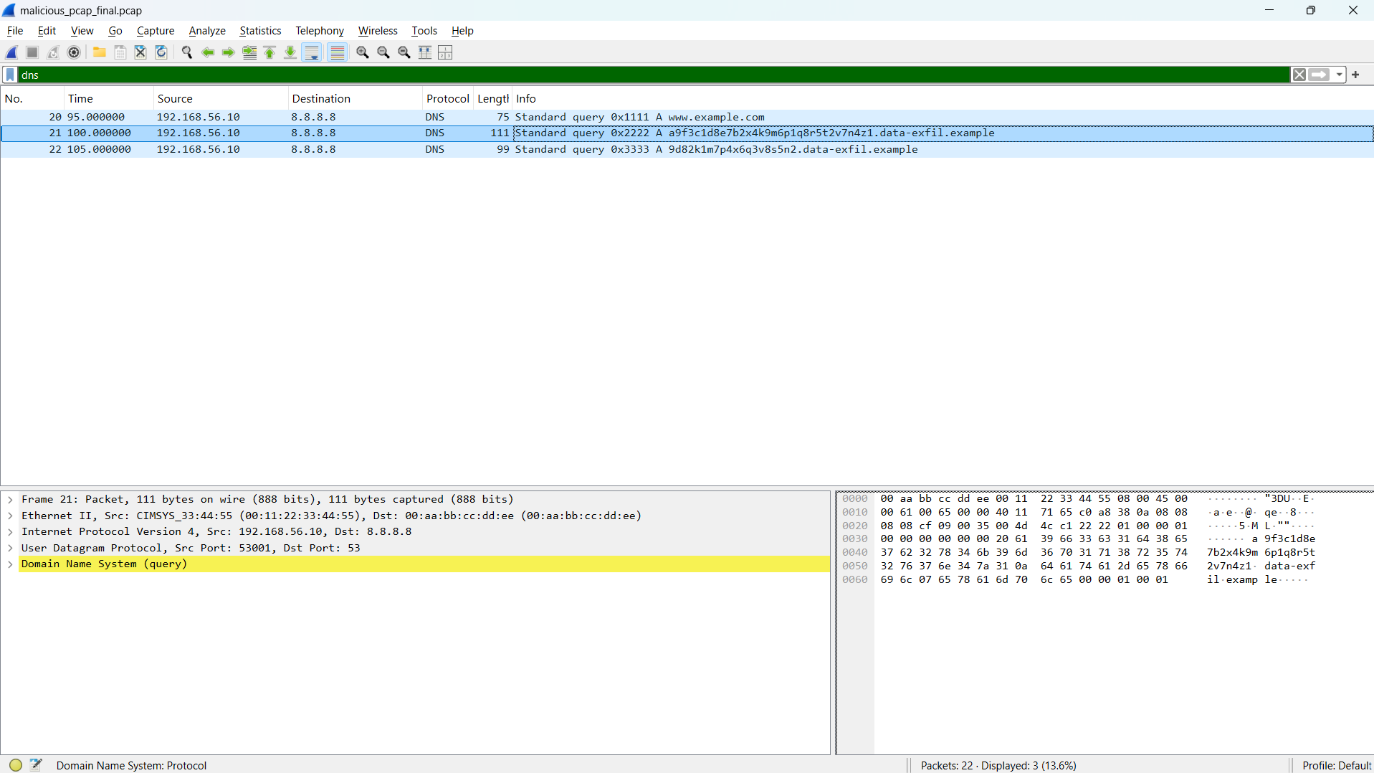
Figure 4: Detection of suspicious DNS query indicating possible DNS tunneling
POC Explanation
We can identify suspicious DNS queries containing long, randomly generated subdomain labels, for example:
a9f3c1d8e7b2x4k9m6p1q8r5t2v7n4z1.data-exfil.example
A long and random-looking DNS subdomain can indicate DNS tunneling, where information is encoded inside DNS queries.
Unlike normal DNS traffic, repeated queries containing large random strings may indicate that DNS is being misused as a communication or data-exfiltration channel.

Step 5: Analyze HTTP Credentials
In the Wireshark Display Filter bar, enter: http
Press Enter.
Look for the HTTP request to: POST /login.php
Select the packet and expand Hypertext Transfer Protocol in the Packet Details section.
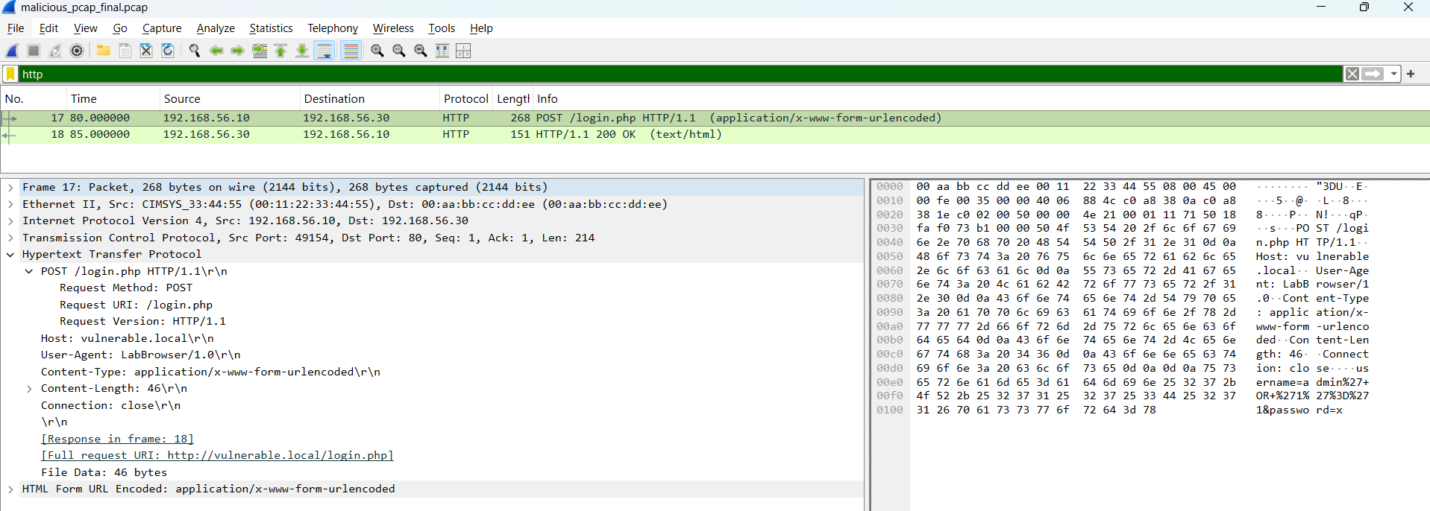
Figure 5: HTTP POST request exposing login credentials and parameters
POC Explanation
The HTTP POST request contains login parameters, including:
username= “admin”
password= “x”
HTTP does not encrypt its contents. Therefore, login information sent through an HTTP POST request can be viewed directly from a packet capture.
This demonstrates the risk of transmitting sensitive credentials over unencrypted HTTP.

Step 6: Identify SQL Injection Payload
Continue analyzing the HTTP POST packet from Step 5.
Look at the username parameter in the HTTP request. The value is URL-encoded as:
admin%27+OR+%271%27%3D%271
This can be decoded as:
admin' OR '1'='1
The suspicious part of the request is: ' OR '1'='1
We can also inspect the corresponding HTTP response and observe:
HTTP/1.1 200 OK
Login accepted
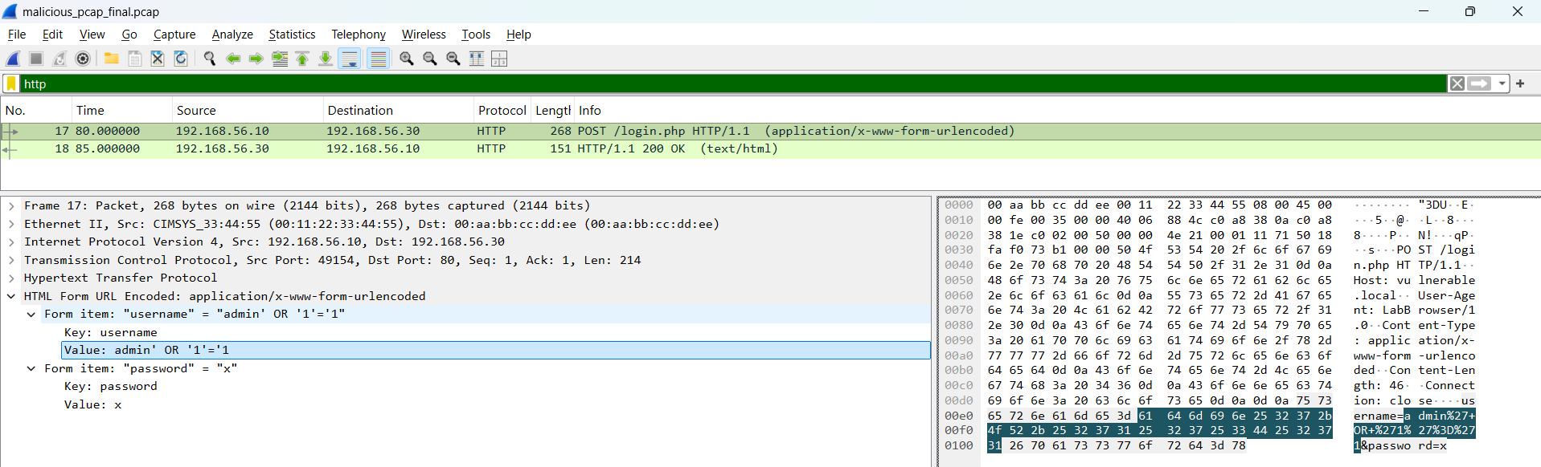
Figure 6: SQL injection payload detected in HTTP request
POC Explanation
The payload attempts to modify the application's SQL authentication condition. Since '1'='1' is always true, this type of input can be used to attempt an SQL Injection authentication bypass.
The successful response makes the activity suspicious and indicates that the vulnerable application accepted the crafted request.

Step 7: Reconstruct the Network Attack Timeline
Now we combine the observations from the previous steps and arrange them in chronological order using the Time, Source, Destination, Protocol, and Info columns in Wireshark.
POC
The observed attack sequence can be summarized as:
- FTP authentication — credentials are transmitted in plain text.
- FTP file access — RETR confidential.txt is used to request a file.
- HTTP login request — POST /login.php contains login parameters.
- SQL Injection — admin' OR '1'='1 is submitted as the username.
- Successful response — the server returns HTTP 200 OK and Login accepted.
- DNS anomaly — unusually long/random DNS queries are observed, indicating possible DNS tunneling or data exfiltration.
A network attack timeline helps us understand the relationship between individual packets and reconstruct the overall sequence of suspicious activities.
Observation
- FTP credentials were exposed in plain text.
- FTP was used to request confidential.txt.
- HTTP transmitted login information without encryption.
- A SQL injection payload was detected in the HTTP request.
- Suspicious DNS queries containing long/random subdomains were identified.
- The captured activities can be correlated using packet timestamps.
Conclusion
The malicious PCAP was successfully analyzed using Wireshark. The analysis identified plain-text FTP credentials, suspicious FTP file access, exposed HTTP login data, SQL injection activity, and abnormal DNS queries. These findings were used to reconstruct the sequence of suspicious network activities.
Observation Questions
1. Which FTP credentials are visible in plain text and which protocol will replace FTP to prevent this?
The FTP capture exposes credentials such as msfadmin / msfadmin in plain text. Traditional FTP should be replaced with SFTP (SSH File Transfer Protocol), which encrypts authentication and file transfers.
2. What is DNS tunneling, and why is it difficult to detect using a simple firewall rule?
DNS tunneling is a technique in which attackers encode data or commands inside DNS queries or responses. It is difficult to detect with a simple firewall rule because DNS is legitimate traffic and normally uses UDP port 53. A basic rule cannot easily distinguish normal DNS queries from malicious DNS tunneling.

Practical-4

AIM: “To analyze an event, set up firewall tools, Identify and collect misconfigurations and design a secure network topology for a sample organization using DMZ and IDS.”

Requirements
- Tool: draw.io / diagrams.net
- Firewall rule table
- Basic network topology components

Network Scheme
Network / Device | IP Address
External Network | 203.0.113.0/24
Gateway | 203.0.113.1
Firewall WAN | 203.0.113.2
DMZ Network | 192.168.20.0/24
Web Server | 192.168.20.10
Internal LAN | 192.168.10.0/24
File Server | 192.168.10.20
DNS Server | 192.168.10.30
Workstations | 192.168.10.100 – 200
Firewall LAN | 192.168.10.1

Misconfigured Firewall Rules
Action | Protocol | Source IP | Destination IP | Port
DENY | HTTPS | Any | 192.168.20.0/24 | 443
ALLOW | FTP | Any | 192.168.10.30 | 22
ALLOW | IP | Any | Any | Any

Misconfigurations
- HTTPS rule: It denies HTTPS traffic to the complete DMZ network instead of allowing it only to the required web server.
- FTP rule: It allows FTP traffic to an internal server and uses port 22, which is not the normal FTP port.
- ALLOW IP Any Any Any: This allows unrestricted traffic and is unsafe.

Corrected Firewall Rules
Action | Protocol | Source IP | Destination IP | Port
ALLOW | HTTPS | Any | 192.168.20.10 | 443
DENY | FTP | Any | 192.168.10.0/24 | 21
DENY | IP | Any | Any | Any

Network Topology
The external network represents the untrusted Internet. Incoming traffic first passes through the IDS, which monitors traffic for suspicious activity such as scans or unusual packets. It then reaches the firewall.
The firewall separates the network into:
- DMZ: contains the public Web Server 192.168.20.10.
- Internal LAN: contains the DNS server, File Server and user workstations.
The Web Server is kept in the DMZ so that a compromise of the public-facing server does not directly expose the internal network. This DMZ concept is common to both source practicals.

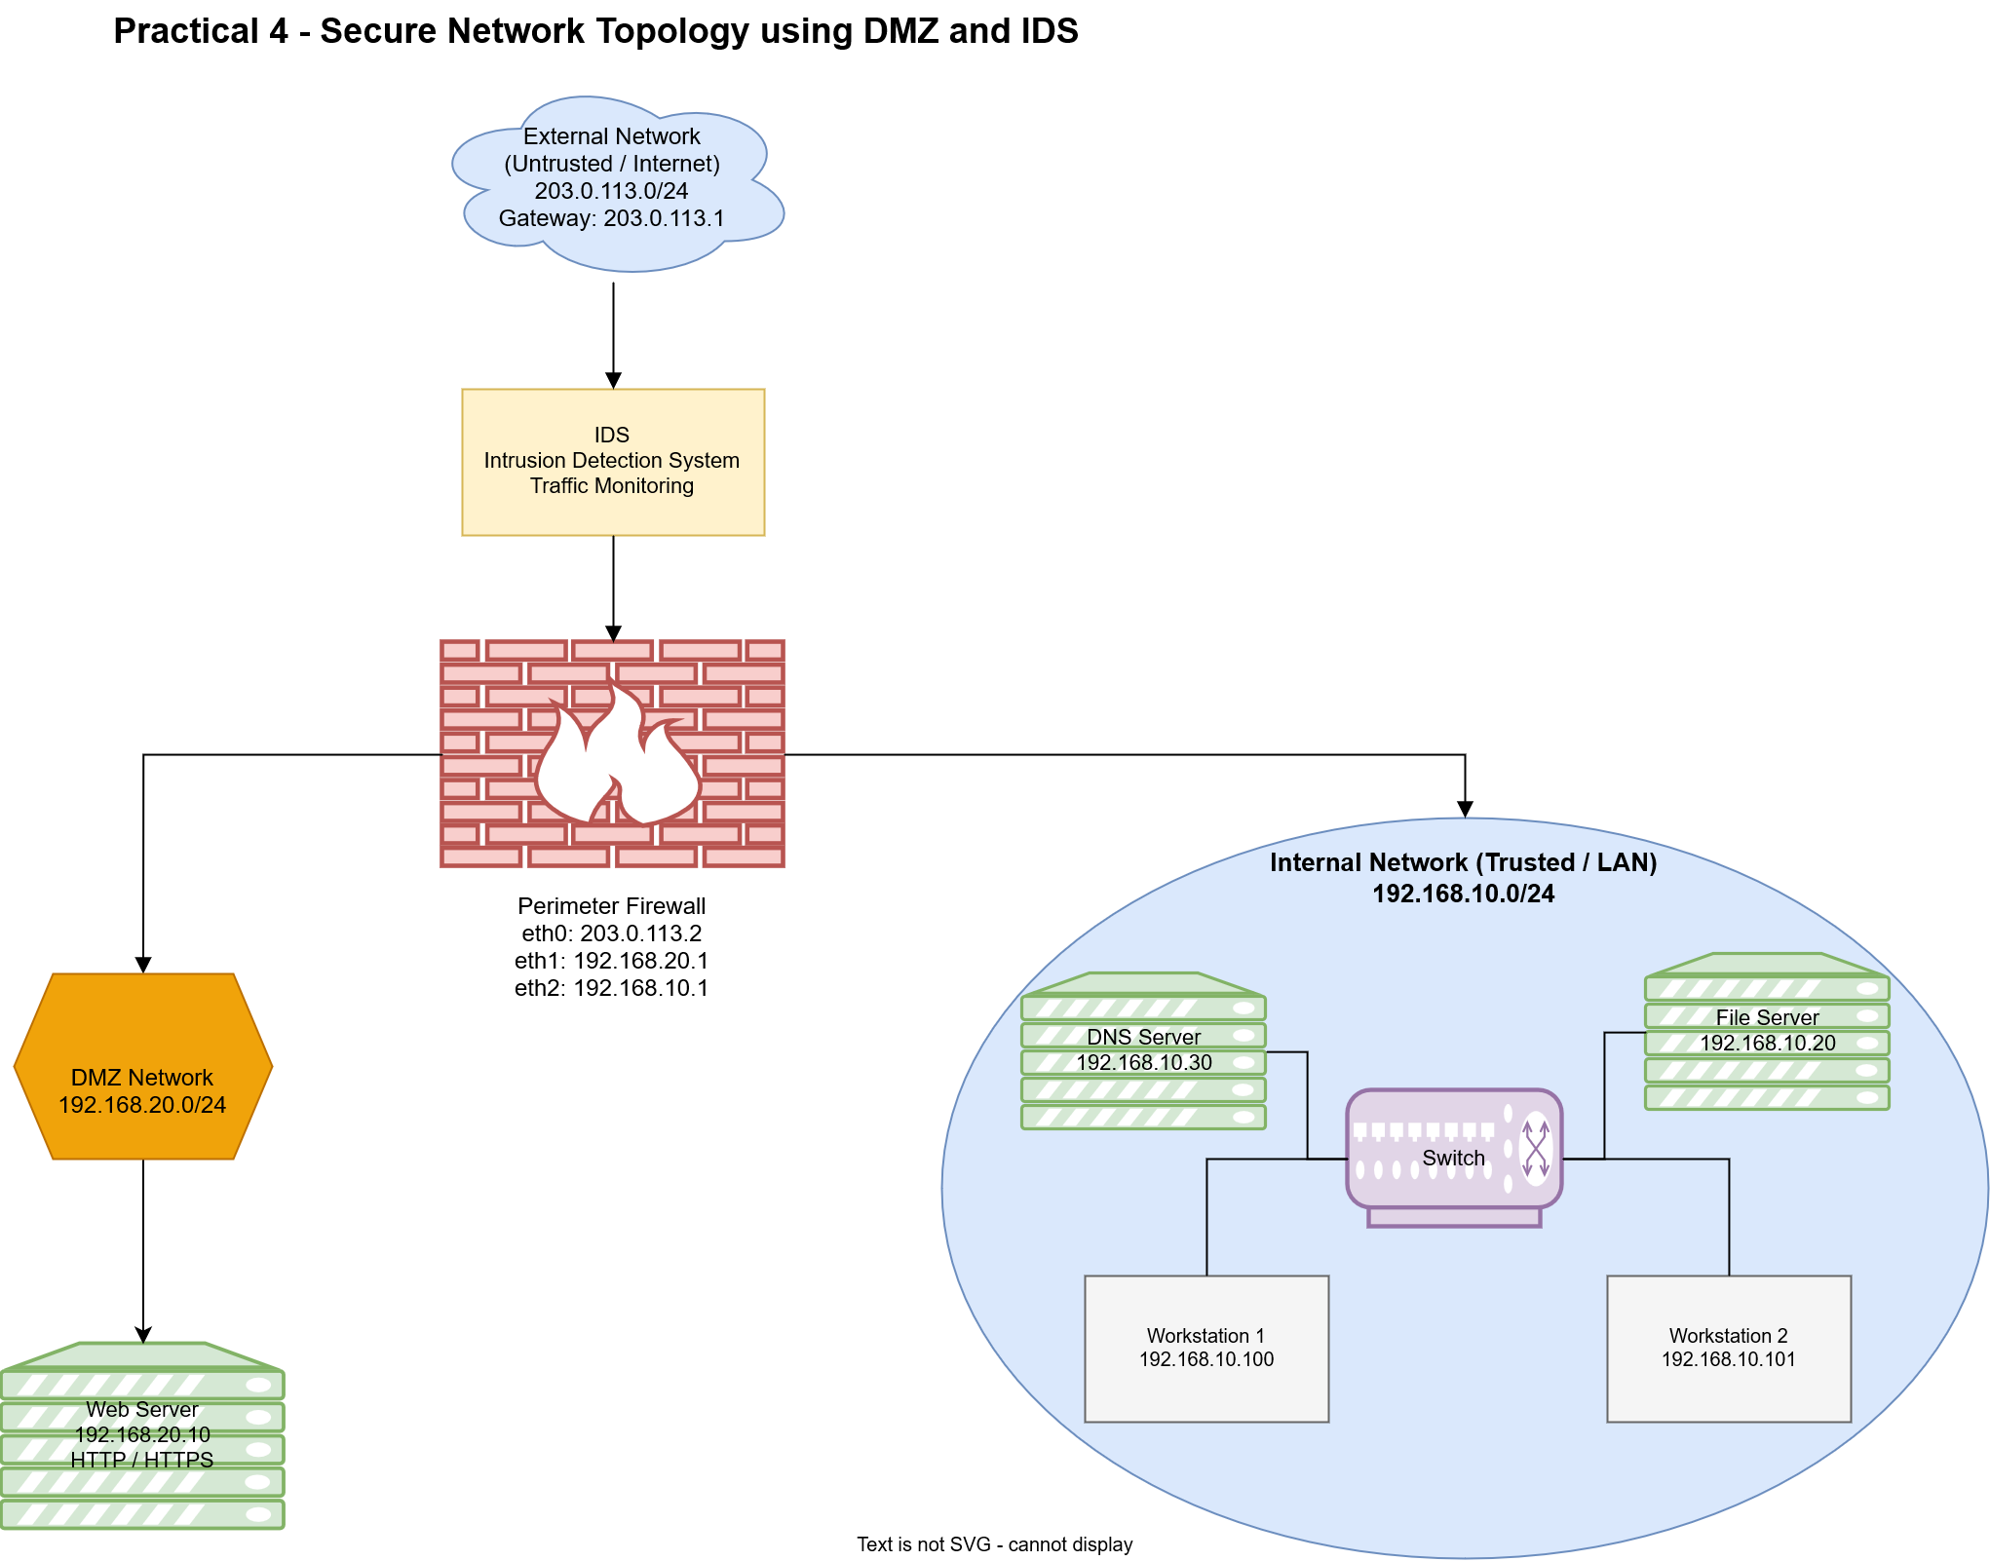
Figure 5: Secure Network Topology using DMZ, Firewall and IDS
POC Explanation
The topology shows traffic flowing from the External Network IDS Firewall DMZ/Internal Network.
The IDS monitors incoming traffic for suspicious activity.
The firewall controls and filters network traffic.
The DMZ contains the public Web Server, while the internal LAN contains trusted servers and workstations.
This separation helps protect internal resources from external threats.
Conclusion

In this practical, the given firewall rules were analyzed and the main misconfigurations were identified. Three rules were corrected by restricting HTTPS to the DMZ web server, blocking FTP access to the internal network, and denying unspecified traffic. A secure network topology was also designed using a DMZ, firewall and IDS. The web server was placed in the DMZ so that it can provide public services without being directly connected to the internal LAN. The IDS was placed near the network perimeter to monitor suspicious traffic.

Observation Questions

1) What is the purpose of DMZ?
A DMZ (Demilitarized Zone) separates public-facing services from the internal network and provides an additional layer of security.

2) Why should a web server not sit directly on the internal network?
A web server is exposed to external users and may be attacked or compromised. Keeping it in a DMZ prevents an attacker from gaining direct access to the internal network.

3) A firewall rule says:
Allow → TCP → ANY → ANY → 443
Why is it dangerous even though 443 is HTTPS?
Port 443 provides encrypted HTTPS communication, but allowing traffic from ANY source to ANY destination is overly permissive. If an exposed service is vulnerable, attackers may still reach it through port 443. The source and destination should be restricted to only what is required.

Practical-5

AIM: “Configure multiple vlan on a switch and test inter vlan communication with a router on stick cisco packet tracer.”

Requirements
- CISCO Packet Tracer
Procedure
Step 1: Create the Network Topology and Connect the Devices
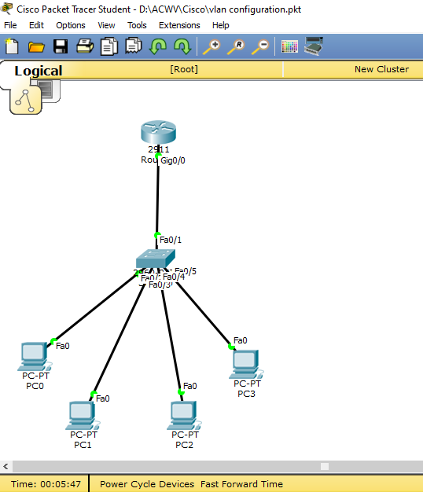
Figure 1: Basic Network Topology with Router, Switch and PCs
In this step, I placed one router, one switch, and four PCs in Cisco Packet Tracer. I connected the router to the switch and connected all four PCs to the switch. At this stage, I have only created the network topology and made the connections. No VLAN or router configuration has been done yet.
Step 2: Create and Name VLANs
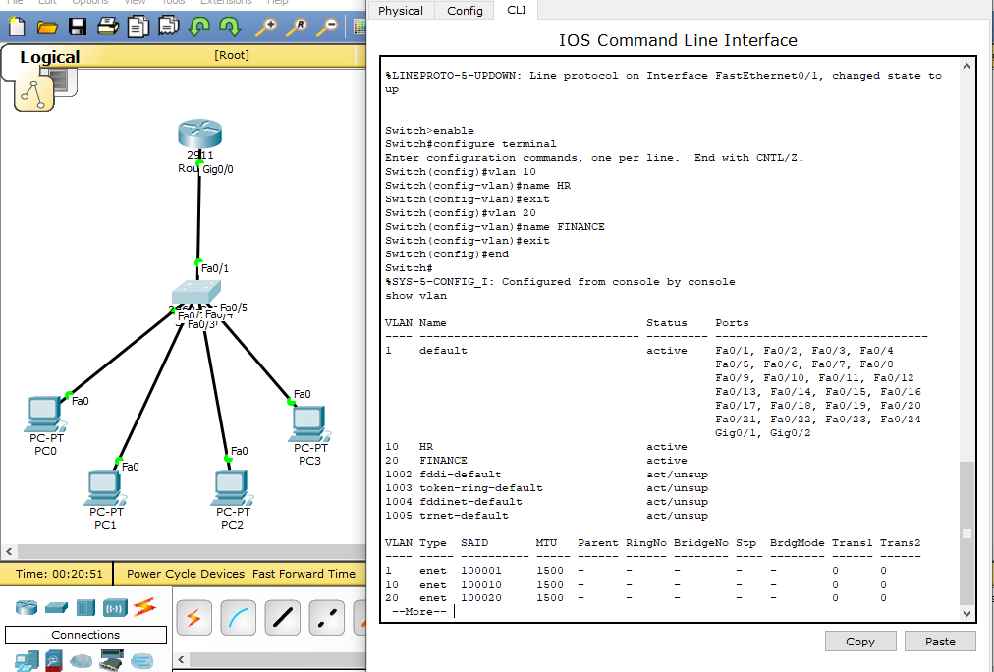
Figure 2: Creating VLAN 10 (HR) and VLAN 20 (FINANCE)
In this step, I created two VLANs on the switch using the CLI. VLAN 10 was named HR and VLAN 20 was named FINANCE. The show vlan command was used to check whether both VLANs were created successfully. At this stage, the VLANs are created but the switch ports are not assigned to them yet.

Step 3: Assign Switch Ports to VLANs
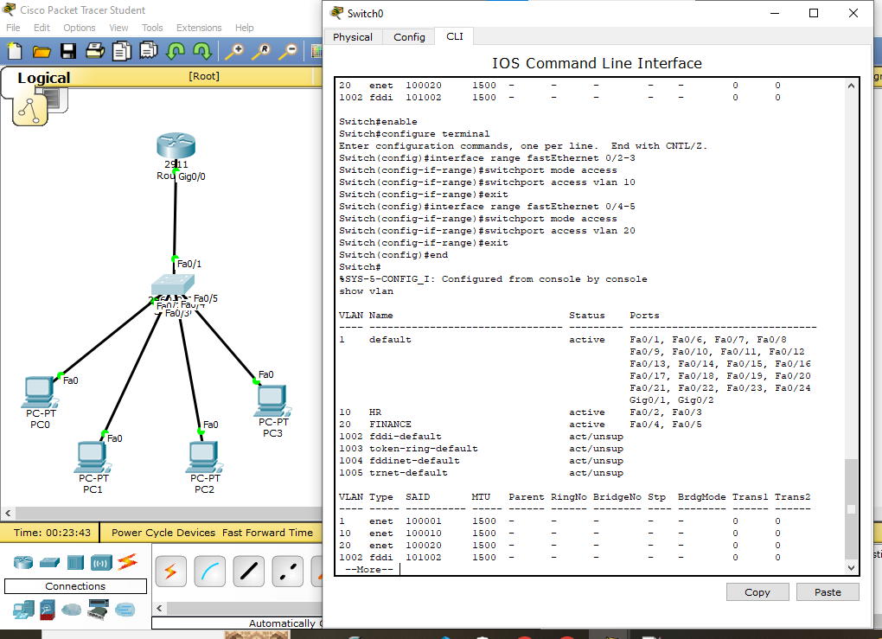
Figure 3: Assigning Switch Ports to VLAN 10 and VLAN 20
In this step, I assigned the switch ports to their respective VLANs using the CLI. Ports Fa0/2 and Fa0/3 were assigned to VLAN 10 (HR), and ports Fa0/4 and Fa0/5 were assigned to VLAN 20 (FINANCE). The show vlan command was used to verify the VLAN names and assigned ports. The output shows that the ports are successfully assigned to their respective VLANs.

Step 4: Start and Configure the Router Interface
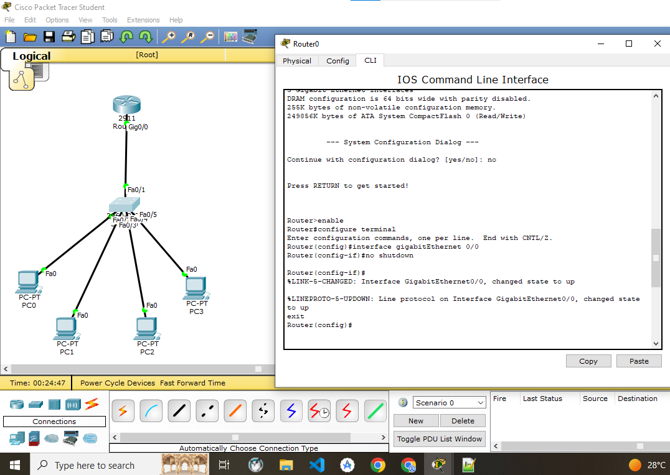
Figure 4: Enabling Router GigabitEthernet Interface
In this step, I started the router configuration using the CLI. I entered the GigabitEthernet 0/0 interface and used the no shutdown command to enable it. The message shows that the interface and line protocol changed to the up state. The router interface is now ready for further configuration.

Step 5: Configure Router Sub-Interfaces for VLANs
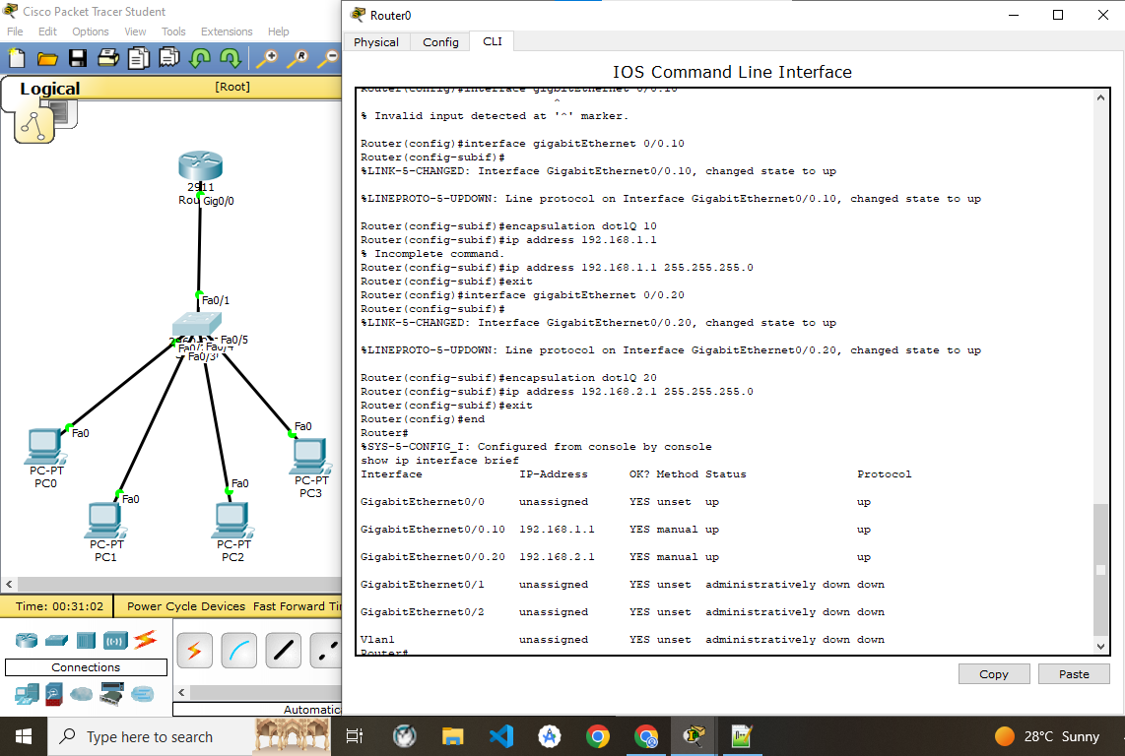
Figure 5: Configuring Router Sub-Interfaces for VLAN 10 and VLAN 20
In this step, I created two sub-interfaces on GigabitEthernet 0/0 for the two VLANs. For VLAN 10, I used IP address 192.168.1.1 and for VLAN 20, I used 192.168.2.1. I also configured 802.1Q encapsulation using VLAN IDs 10 and 20. The show ip interface brief command was used to verify that both sub-interfaces are up.

Step 6: Configure the Switch Port as Trunk
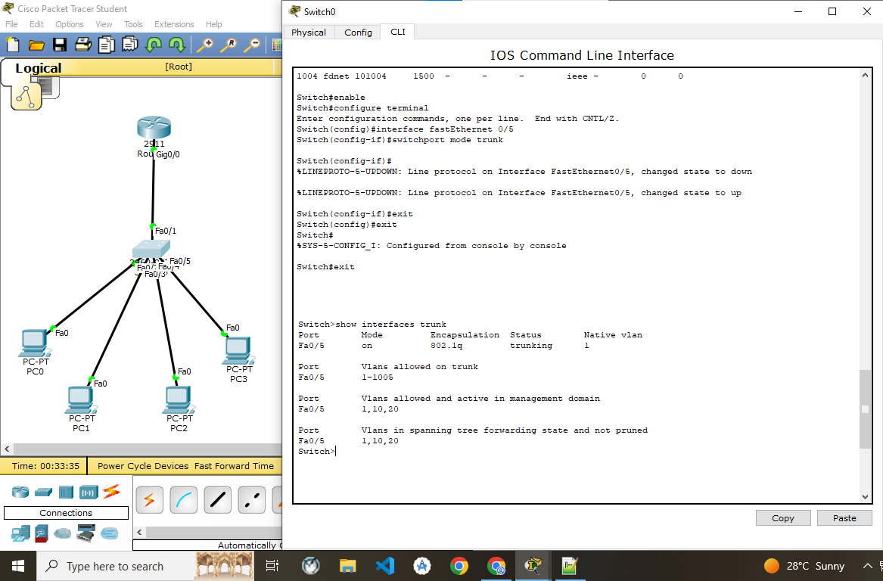
Figure 6: Configuring FastEthernet 0/5 as Trunk Port
In this step, I configured FastEthernet 0/5 of the switch as a trunk port. I used the switchport mode trunk command for this configuration. The show interfaces trunk command was used to verify the trunk configuration. The output shows that Fa0/5 is working in trunk mode with 802.1Q encapsulation.

Step 7: Test Inter-VLAN Communication
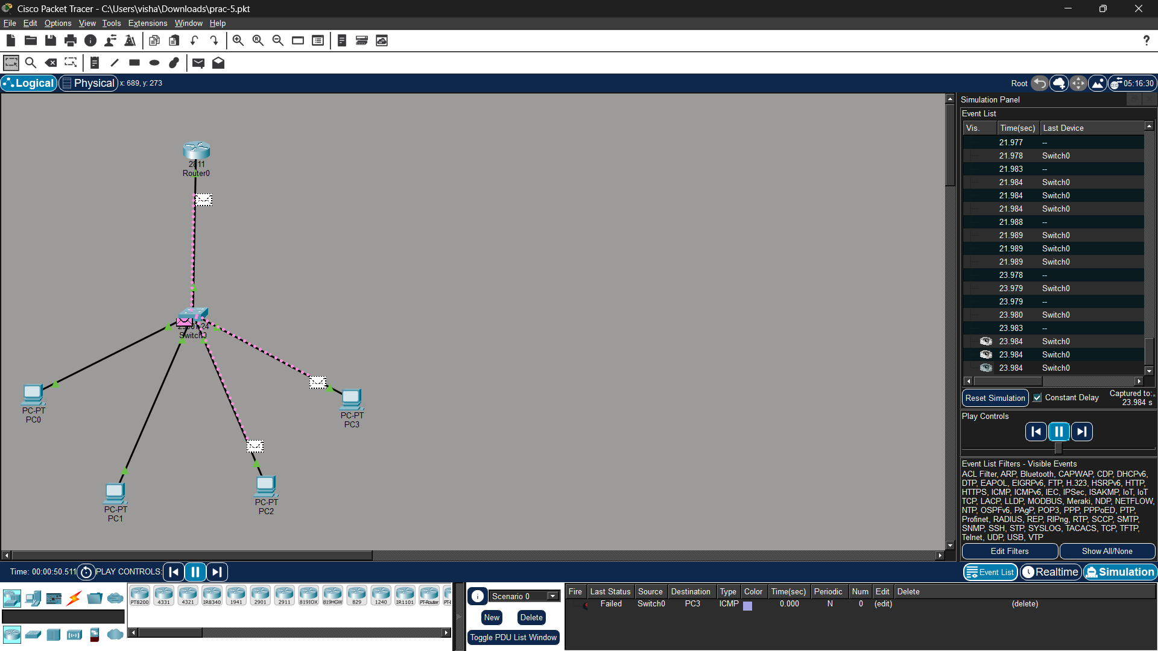
Figure 7: Testing Packet Transfer Between VLANs
In this step, I used Simulation Mode in Cisco Packet Tracer to test communication between the PCs. I sent an ICMP packet from PC0 to PC3 to check communication between the two VLANs.
The Event List shows that the packet transfer was failed in this test. This shows that the inter-VLAN communication still needs to be checked and configured correctly.

Conclusion
The network was created in Cisco Packet Tracer using one router, one switch, and four PCs. VLAN 10 (HR) and VLAN 20 (FINANCE) were created and the PC ports were assigned to their respective VLANs. The router sub-interfaces and trunk link were configured for Router-on-a Stick inter-VLAN communication. In the final simulation shown, the ICMP packet from PC0 to PC3 failed, so the inter-VLAN communication was not successfully confirmed in this test.

Observation Questions
Q1. What is the purpose of creating VLAN 10 and VLAN 20 on the switch?
Ans: VLANs are created to divide the network into separate logical groups.
- VLAN 10 – HR: Used for PC0 and PC1.
- VLAN 20 – FINANCE: Used for PC2 and PC3.
- They separate the broadcast traffic between the two groups.
- Router-on-a-Stick is used to allow communication between the two VLANs.

Q2. How does VLAN segmentation affect communication between PCs?
Ans: VLAN segmentation separates PCs into different logical networks. PC0 and PC1 are in VLAN 10, while PC2 and PC3 are in VLAN 20. PCs within the same VLAN can communicate directly, but communication between different VLANs requires a router or Layer 3 device. This helps organize the network and separates broadcast traffic.

Q3. Why is the link between the switch and router configured as a trunk link?
Ans: The link between Switch0 Fa0/1 and Router0 G0/0 is configured as a trunk link. It carries traffic from both VLAN 10 and VLAN 20 through one physical connection. The trunk uses 802.1Q encapsulation to identify the VLAN traffic. This allows the router to handle communication between the two VLANs.

Q4. What would happen if the switch-to-router link were configured as an access port?
Ans: An access port can carry traffic for only one VLAN. If the Switch0 Fa0/1 link to Router0 was configured as an access port, it could not properly carry traffic from both VLAN 10 and VLAN 20. As a result, communication between the two VLANs would not work correctly. Therefore, Fa0/1 is configured as a trunk port in this practical.

Q5. Why is a router required for inter-VLAN communication?
Ans: VLAN 10 and VLAN 20 are separate logical networks, so a Layer 2 switch cannot directly route traffic between them. The router provides a gateway for each VLAN using its sub-interfaces. In this practical, G0/0.10 is the gateway for VLAN 10 and G0/0.20 is the gateway for VLAN 20. The router is used to route traffic between the two VLANs.

Q6. What role does the default gateway play?
Ans: The default gateway is used by a PC to communicate with devices in another network or VLAN. In this practical, PC0 and PC1 use 192.168.1.1 as their default gateway. PC2 and PC3 use 192.168.2.1 as their default gateway. These gateway addresses are configured on the router's VLAN sub-interfaces.

